OCTOBER

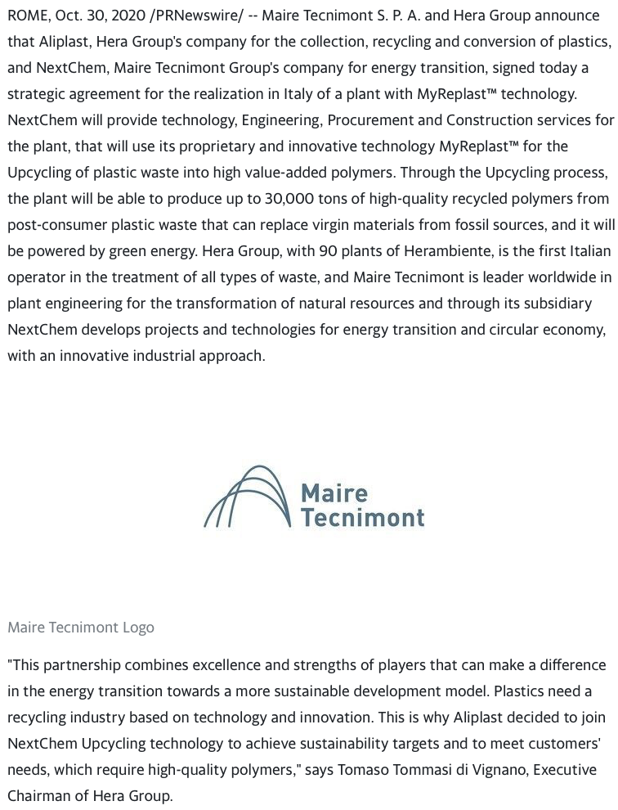
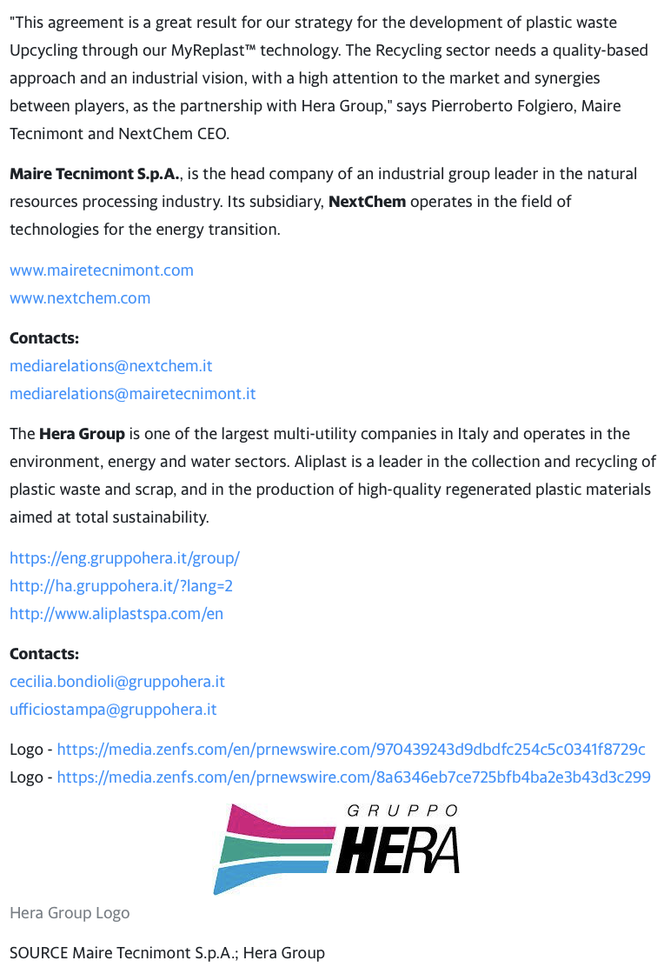

Link: https://finance.yahoo.com/news/aliplast-nextchem-signed-agreement-plastics-210500251.html?guccounter=1

